**Pizza sales queries**

**KPI’S**

1. select round(sum(total_price * quantity),2) as total_revenue from pizza_sales;

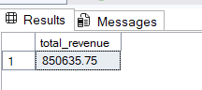

select round(sum(total_price * quantity),2) as total_revenue

from pizza_sales;

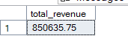

select (sum(total_price * quantity)) / count (distinct order_id) as avg_order

from pizza_sales;

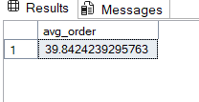

select sum(quantity) as total_pizza_sold from pizza_sales;

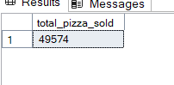

select count(distinct order_id) as total_orders from pizza_sales;

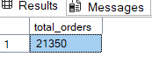

select sum(quantity)/count(distinct order_id) as avg_pizza_per_orders from pizza_sales;

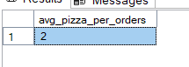

2. % Of Sales by Pizza Category

select pizza_category , round((sum(total_price)*100)/(select sum(total_price) from pizza_sales) , 2) as sales_PCT

from pizza_sales

group by pizza_category;

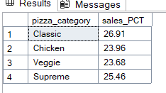

3. % Of Sales By Pizza Size

select pizza_size , round((sum(total_price)*100)/(select sum(total_price) from pizza_sales) , 2) as sales_PCT

from pizza_sales

group by pizza_size;

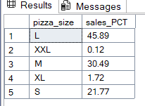

select pizza_category , round(sum(quantity)/(select sum(quantity) from pizza_sales) , 2) as sales_PCT

from pizza_sales

group by pizza_category;

Monthly Trend For Total Orders

select DATENAME(month, order_date) as month_name , count(distinct order_id) as total_orders

from pizza_sales

group by DATENAME(month, order_date)

order by total_orders desc;

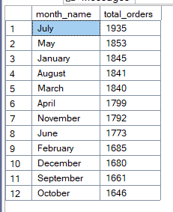

Top 5 Order By Revenue

select top 5 pizza_name , sum(total_price) as total_price

from pizza_sales

group by pizza_name

order by total_price desc;

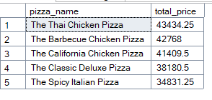

Top 5 Order By Quantity

select top 5 pizza_name , sum(quantity) as total_quantity

from pizza_sales

group by pizza_name

order by total_quantity desc;

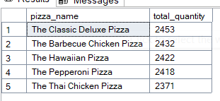

Top 5 Order By Total order

select top 5 pizza_name , count(distinct order_id) as total_orders

from pizza_sales

group by pizza_name

order by total_orders desc;

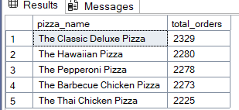

Bottom 5 Order By Revenue

select top 5 pizza_name , sum(total_price) as total_price

from pizza_sales

group by pizza_name

order by total_price asc;

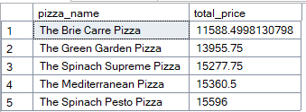

Bottom 5 Order By Quantity

select top 5 pizza_name , sum(quantity) as total_quantity

from pizza_sales

group by pizza_name

order by total_quantity asc;

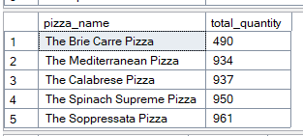

Bottom 5 Order By Total order

select top 5 pizza_name , count(distinct order_id) as total_orders

from pizza_sales

group by pizza_name

order by total_orders asc;

